Senior Project II

ERIC III
BY:
Karthik Kesavan
Jignasha Patel

Mark Riegert
Stephen Martin

Instructor: Dr. E.T. Dickerson

Outline report of ongoing project
NOV 18th 2002

I INTRODUCTION

A. OBJECTIVES

The objective of this project is to design a GPS controlled robotic car that is implemented by using a PIC micro controller that controls two separate H-bridges for wheel movement. A digital compass is also used in order to perform the operation of navigating the car from one location to another.

II PROJECT OVERVIEW

A. BLOCK DIAGRAM OF SYSTEM
Note: the Tach has been removed from the design as the cars movement is slow enough not to require it.

B. CAR CONTROL

1. Car will be controlled by a PIC 16f877
2. Micro controller with an embedded program
3. Program is C code compiled to PIC Assembly by a PIC C compiler
4. Navigation Information from two sources
a. Digital Compass (Dinsmore 1525)
b. GPS

C. NAVIGATION OF ERIC III

1.DIGITAL COMPASS
a. Maintain Tracking of the car
b. Supply known direction and orientation of car for navigation calculations.

2. GPS:
a. Beacon Receiver required to Pick up Differential
b. GPS correction information
c. GPS Receiver that utilizes an H-field Antenna
d. GPS info is standard NMEA format that will be input to PIC UART
interface

III DESIGN & CONSTRUCTION

A. REQUIREMENTS & SPECIFICATION OF CHASSIS:
Requirements & Specifications for the robotic car chassis are as follows:

1. Height: 11 inches
2. Width: 28 inches
3. Length: 25 inches
4. Ground clearance: 3.25 inches
5. Load capacity: 45 pounds
6. Maximum speed 1foot/ 3 seconds
7.Wheels and pneumatic tires: 11 inches in diameter by 4 inches
8. Max current load: 1.2 amps
9. Charging time: 4 hours at 6amps
10. Optical encoder resolution: 90/180 per revolution
11. Encoder sensor: OPB704 reflective type combining LED and Phototransistor (tach available but not used this project)

B. PROBLEMS IN PREVIOUS DESIGN OF CHASSIS:
1. Non linear steering (due to arc of servo arm and related linkage)
2.Change of direction must occur as the device follows an arc
3. Load capacity limits electronic and mechanical components that can be installed.

These problems required a different car to be designed.

C. PRESENT CHASSIS DESIGN:

1. BLOCK DIAGRAM OF INCREMENTAL CONTROL SYSTEM:

2. MECHANICAL DESIGN

D. HARDWARE DESIGN

1. REQUIREMENTS:
a. PIC16F877
b. Digital Compass
c. Tachometer
d. GPS

2. BLOCK DIAGRAM

3. BASIC PIC INTERFACE
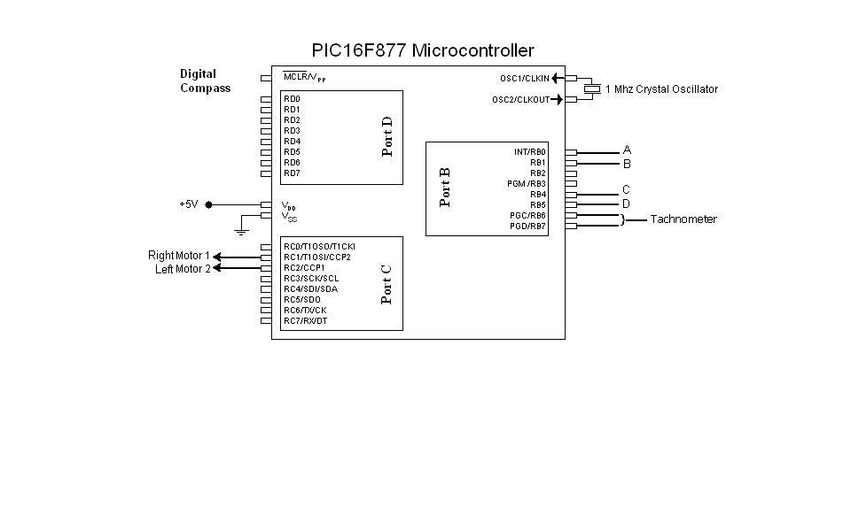

4. H-BRIDGE MOTOR CONTROL ( There are two bridges, one for each wheel.)

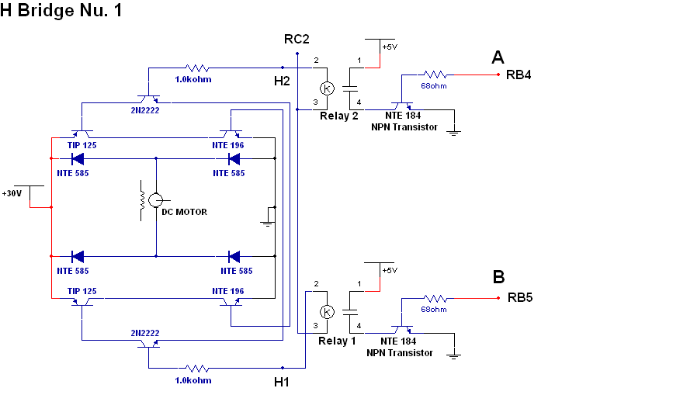

D. SOFTWARE & DATA FLOW

1.DATA FLOW OF MAIN FUNCTION

2. DATA FLOW OF MOVE CAR IN DIRECTION OF GOAL FUNCTION

3. ORIENT CAR TO GOAL FUNCTION

IV DESIGN TRADE OFFS

A. STEERING:

1. PWM controlled steering servo used on previous version
2. Control each wheel separately
We chose B as it enables better direction movement (full 360º around itself)

B. CAR DESIGN:

1. Build a Larger Car
2. Use previous version

Chose A as we need bigger platform for hardware and available motors were large.

C. DIGITAL COMPASS:

1. Eight directions of heading information
2. Compass with 2º accuracy
We chose B because the need of tracking on a heading requires accuracy .

D. GPS ANTENNA:

1. H-Field
2. E-Field
Chose A because E-Field requires grounding.

V PLAN OF DESIGN AND CONSTRUCTION

A. Get the car designed and build it (done)

B. Build the hardware (done) and interface it to the car.

C. Create a Basic Program to test the interface of hardware to the car.
1. Drive of the car (done)
2. Steering capability and response (done)

D. Code more advanced program to navigate from a known position to another with simulated GPS positioning information. (done)

E. Create functions necessary for GPS utilization.

F. Interface GPS to the car when GPS arrives from vendor.

If GPS does not arrive in time, we will have to simulate GPS Positioning by developing a grid system that will demonstrate the capabilities of the car to turn to a known calculated heading and track to a preselected coordinate.

Am presently working on the code for this.

